AP Calculus AB
2014-15 Summer Homework
Unit 2 – Parent Functions

Identifying Parent Functions & Symmetries Assignment

Directions: Identify the parent function and symmetry for each of the pictured graphs.

 | Graph | Function | Symmetry
1. | 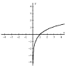
2. | 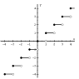
3. | 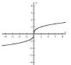
4. | 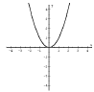
5. | 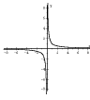
6. | 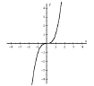
7. | 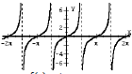
8. | 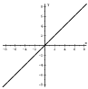
9. | 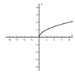
10. | 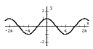
11. | 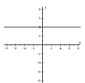
12. | 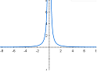
13. | 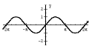
14. | 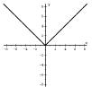
15. | 